**Ideation Phase**

**Define the Problem Statements**

|  |  |
| --- | --- |
| Date | 19 September 2022 |
| Team ID | PNT2022TMID23604 |
| Project Name | Skill and Job Recommender |
| Maximum Marks | 2 Marks |

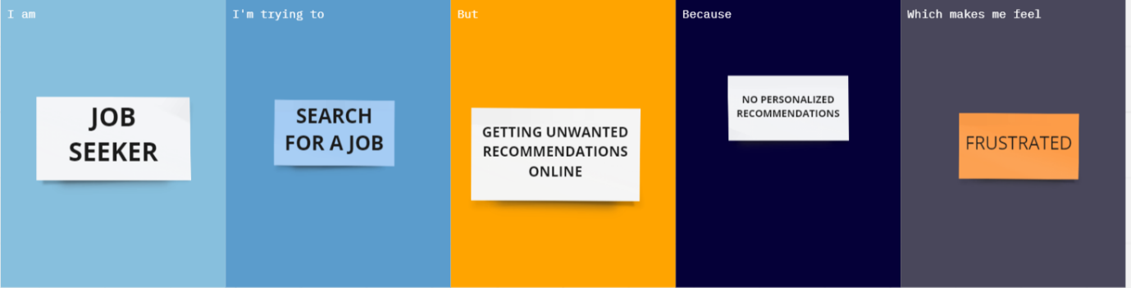



|  |  |  |  |  |  |
| --- | --- | --- | --- | --- | --- |
| **Problem Statement (PS)** | **I am (Customer)** | **I’m trying to** | **But** | **Because** | **Which makes me feel** |
| PS-1 | JOB SEEKER | SEARCH FOR A JOB | GETTING UNWANTED RECOMMENDATIONS ONLINE | NO PERSONALIZED  RECOMMENDATIONS | FRUSTRATED |
| PS-2 | JOB SEEKER | SEARCH FOR A JOB | CANNOT FIND A JOB | EXPECTATIONS NOT MET | FRUSTRATED |